Chapter 10, Problem 87.

Determine V₁, V₂, and V₃ in the circuit of Fig. 10.129 using PSpice.
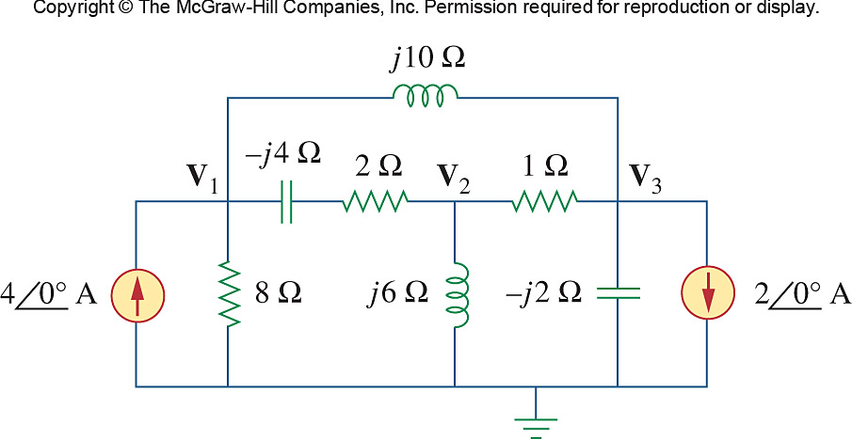

Figure 10.129
For Prob. 10.87.

